Brain tumours

Are brain tumours in pets treatable?
It depends on the type of tumour, the location and the treatment options available. The most common type of tumour in dogs and cats is called a meningioma, and this arises from the membranes surrounding the brain. This type of tumour can often be removed via surgery, and a cure is therefore possible in many animals. Even when it is not possible to remove the tumour entirely, pets can return to a normal life for many months or even years before it regrows. Other types of tumour such as glioma are a greater surgical challenge as they grow inside the brain, but treatment options such as radiotherapy are available for all tumour types.

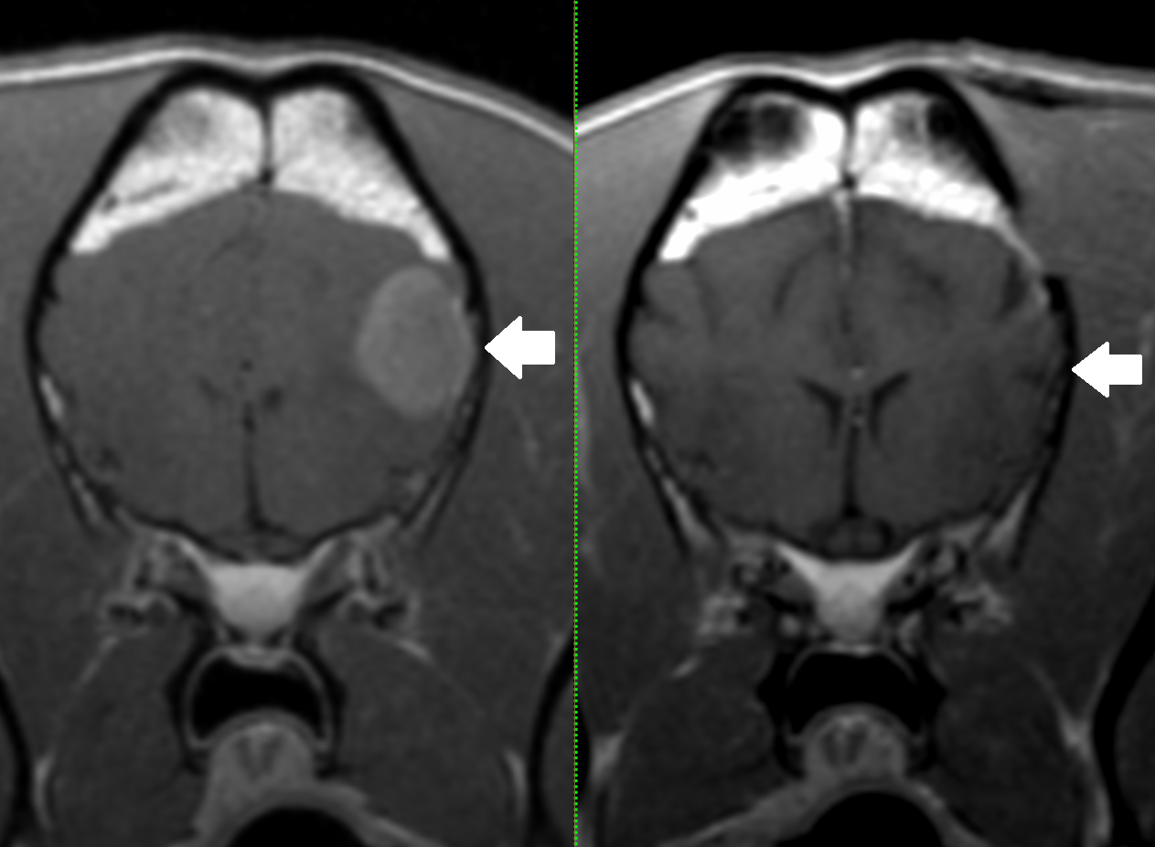
MRI scans of a 7 year old golden retriever that was cured of a brain tumour. The left image shows the tumour, which was diagnosed as a meningioma. The dog had surgery to remove this tumour and had no further seizures afterwards. The right image shows that there was no regrowth of the tumour two years later.

Which animals suffer from brain tumours?
Middle aged to older dogs and cats are most commonly affected.

What are the signs of brain tumours in animals?
The signs depend on the part of the brain affected. However, the most common signs are seizures, a change in personality, walking in circles, balance problems and difficulty walking.

How are brain tumours diagnosed?
The history and examination are an extremely important part of the diagnosis of brain tumours and blood tests may be required to exclude other conditions that can cause similar signs. MRI scanning is the best way to confirm the diagnosis for nearly all conditions affecting the brain. MRI uses high powered magnets and a computer to generate images of the spine (this is the same technique and the same equipment which is used for body scanning in human patients). It provides detailed information on the location and extent of any tumours and their effects on the brain. Whilst MRI is a very important tool, it may ultimately only be possible to confirm the diagnosis for the brain tumour on biopsy examination.

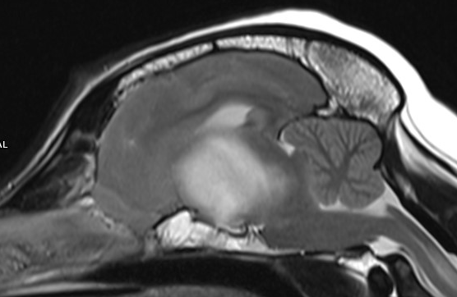
MRI of a dog’s brain showing a glioma (a tumour arising from within the brain).

How can brain tumours be treated?
The three main ways of treating brain tumours are palliative treatment, surgery and radiotherapy.

Palliative treatment
In some pets, the only treatment option available is palliative treatment with anti-inflammatory and ant-seizure medications to reduce the effects of the tumour. Certain types of chemotherapy can be used to slow down growth of the tumour. This type of treatment can improve the signs of the tumour but sadly the beneficial effects usually only last a few weeks to months.

Surgery
At Eastcott, we routinely perform surgery for pets who will benefit from this. After carefully considering the options, many pet owners elect for this treatment as in many cases it offers the best chance of a cure. Cats, in particular, can have an excellent prognosis following brain tumour surgery, and many will be significantly improved within a few days of surgery. We have some of the most advanced equipment available for brain tumour surgery, including an ultrasonic aspirator, microsurgical instruments and titanium mesh for skull reconstruction. Our specialist-led anaesthesia and critical care teams provide outstanding support so that we can provide this service as safely as possible.

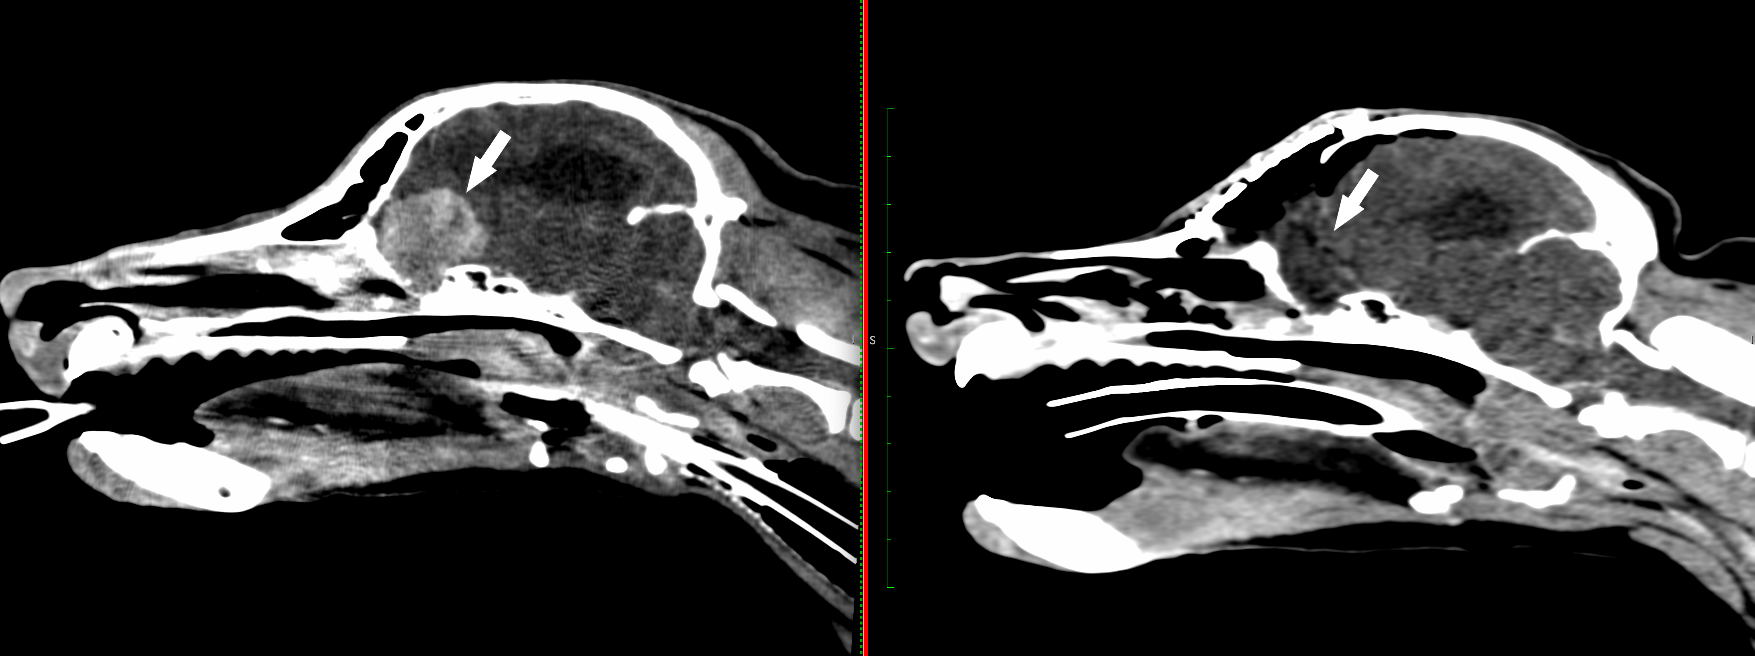
Pre and postoperative scan of a brain tumour that was removed via transfrontal approach. This tumour was a benign meningioma.

Radiotherapy
This treatment is available for all types of brain tumour and is sometimes recommended following surgery. We do not offer this service in-house but if it is required we can arrange referral to another centre in the UK.

