Lumbosacral disease

What is the lumbosacral region?
The lumbosacral region consists of the last disc in the lower back and the joints between the vertebrae (back bones). In this region, there are many important nerves that supply the rear legs, tail, bladder and anus.

How does lumbosacral disease occur?
Lumbosacral disease is a neurological condition in which nerves in the low back region are compressed or trapped. Ageing may result in degeneration and bulging of the lumbosacral disc, which causes the space for these nerves to be narrowing. The underlying cause of the disc degeneration and bulging is unclear, although in some dogs it may be associated with instability of the bones of the spine.

Which animals suffer from lumbosacral disease?
Large breeds of dogs are more commonly affected by this than smaller breeds, and German Shepherd Dogs and Border Collies appear to be particularly prone to the condition. We are also increasingly recognising this condition in cats.

What are the signs of lumbosacral disease?
Lower back pain is the key feature of the disease. Typically, affected animals are reluctant to jump and climb, and they may have difficulty rising from a lying position. Groaning or spontaneous yelping may be signs of pain. Muscle atrophy is also common, particularly in the hamstring muscles. Less common signs include lameness of one or both back legs, incontinence and reduced tail movement.

How is lumbosacral disease diagnosed?
The history and examination are an extremely important part of the diagnosis of Lumbosacral disease. MRI scanning is the best way to confirm the diagnosis in many spinal conditions, including lumbosacral disease. MRI uses high powered magnets and a computer to generate images of the spine (this is the same technique and the same equipment which is used for body scanning in human patients). It provides detailed information on the location and extent of any soft tissue compressions of the spinal nerves in the lumbosacral spine.

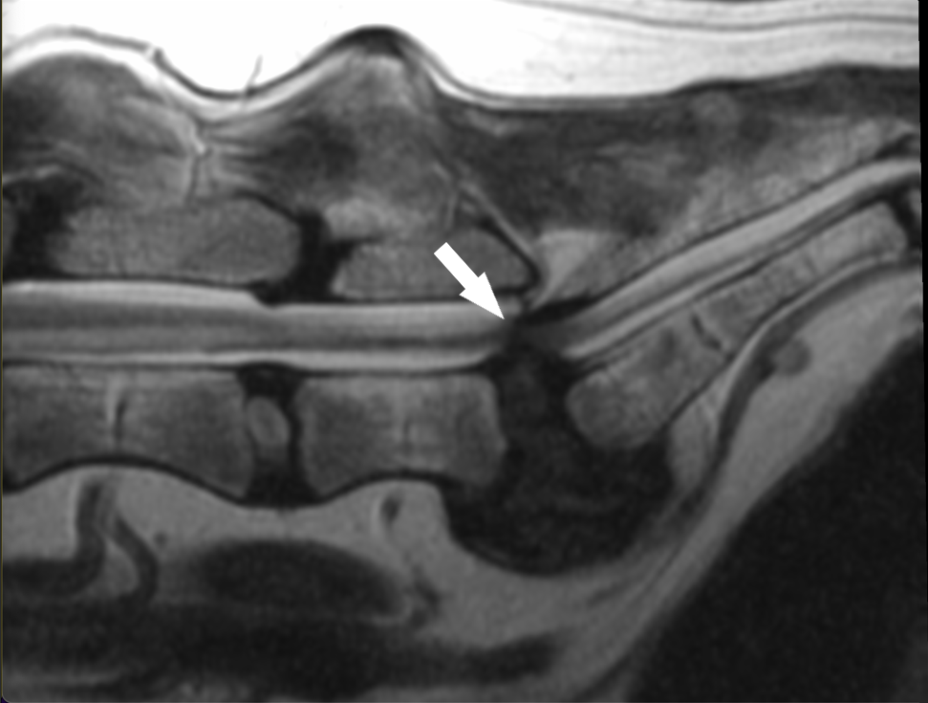
MRI scan of the spine showing lumbosacral disease causing compression of nerves by a bulging disc (arrow)

How can lumbosacral disease be treated?
The three ways of treating lumbosacral disease are conservative treatment, epidural injection and surgery.

Conservative treatment
Some dogs and cats with lumbosacral stenosis can be successfully managed without the need for surgery. It is often necessary to modify exercise with avoidance of strenuous activities that involve jumping, climbing, twisting and turning. Pain relief medications are usually prescribed, and if needed an internal referral can be made to our chronic pain clinic. In particular, anti-inflammatory and neuropathic pain relief medications may be beneficial. Physiotherapy and hydrotherapy can also be useful treatments in certain cases.

Epidural injection
Many animals benefit from this procedure which is carried out under anaesthesia. An injection of a steroid or anaesthetic is directed into the space surrounding the affected nerves. This can greatly reduce pain and swelling in these nerves give very good relief. If needed, it can be repeated every few weeks or months. Our team of specialist-led veterinary anaesthetists provide this in-house service.

Surgery
Some animals with lumbosacral disease require surgery to improve pain, hind limb lameness or weakness and other problems such as incontinence. Various techniques may be performed, and these aim to remove pressure on compressed nerves and/or stabilise the bones in the lumbosacral region. The bones surrounding the lumbosacral disc may be stabilised with screws that are secured with metal bars or cement. We often make use of custom-made 3D printed guides for this purpose.
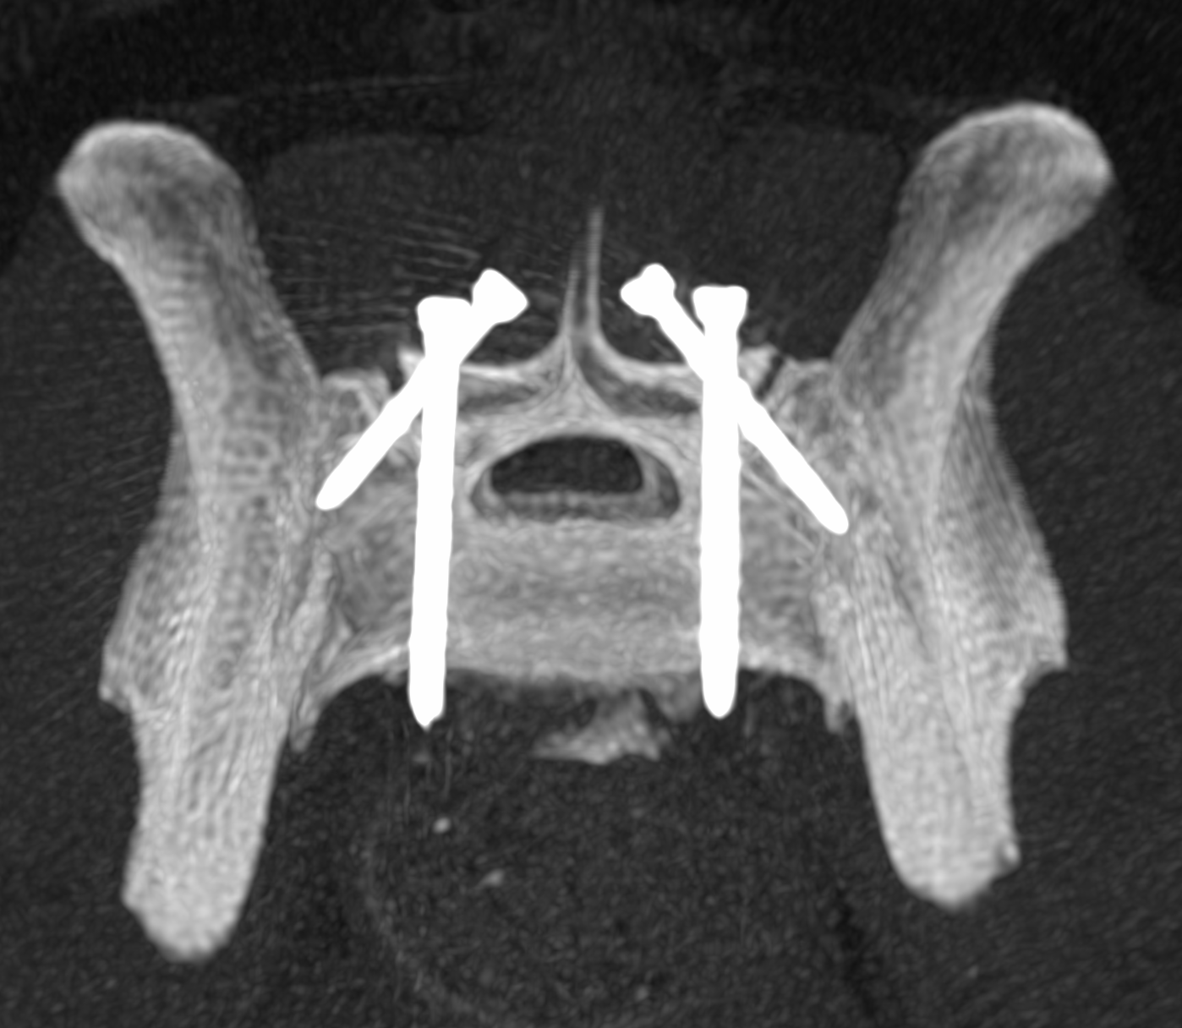
A CT scan performed during surgery to check the accuracy of multiple screws placed into the bones of the lumbosacral region prior to bone cement placement.

What can I expect if my pet is treated for lumbosacral disease?
With any treatment, the aim is to reduce pain and improve mobility. Whilst certain ‘lifestyle’ changes and long-term medications may be necessary to prevent pain, in most cases we aim to return to normal activities such as running and jumping and avoid any long-term medication side effects.

In surgically treated pets, a few days of postoperative hospitalisation is usually required. Following this, a period of exercise restriction is needed.

Regardless of treatment, many pets benefit from physiotherapy, which we provide through our in-house service provided by qualified veterinary physiotherapists.

