‘Wobbler’ syndrome

How does ‘Wobbler’ syndrome occur?
Wobbler syndrome is also known as caudal cervical spondylomyelopathy. This is a neurological condition in which the spinal cord in the neck is damaged by repeated compression. Thickening of joints between the vertebrae (bones in the neck) and ageing and bulging of discs and ligaments may result in narrowing of the canal that contains the spinal cord. The underlying cause of this problem is unclear, although it may be related to vertebrae growing too rapidly and becoming misshapen.

Which animals suffer from lumbosacral disease?
Large and giant breeds of dogs are more commonly affected by this than smaller breeds, and Dobermans, Great Danes and Mastiff-type breeds appear to be particularly prone to the condition. Cats do not appear to be affected.

What are the signs of ‘Wobbler’ syndrome?
Weakness and unsteadiness, particularly in the front legs, is the main sign of the disease. Occasionally, dogs can also show signs of neck pain due to nerve compression.

How is ‘Wobbler’ syndrome diagnosed?
The history and examination are an extremely important part of the diagnosis of Wobbler syndrome. MRI scanning is the best way to confirm the diagnosis in many spinal conditions, including Wobbler syndrome. MRI uses high powered magnets and a computer to generate images of the spine (this is the same technique and the same equipment which is used for body scanning in human patients). It provides detailed information on the location and extent of any spinal cord compressions in the neck.

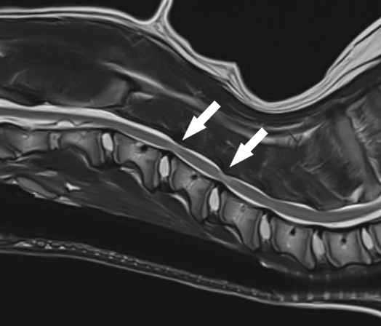
MRI scan of the neck showing ‘Wobbler’ syndrome in a young Great Dane. In this example, thickening and loss of elasticity of the flaval ligament is causing compression of spinal cord in two locations shown with arrows.

How can ‘Wobbler’ syndrome be treated?
The two ways of treating wobbler syndrome are conservative treatment and surgery.

Conservative treatment
Some dogs with Wobbler syndrome stenosis can be successfully managed without the need for surgery. It is often necessary to modify exercise with avoidance of activities that cause a strain on the neck. A chest harness will be recommended over a neck lead, and ‘Halti’ muzzles and tug-of-war games are to be especially avoided. Pain relief medications are sometimes prescribed, and if needed an internal referral can be made to our chronic pain clinic. In particular, anti-inflammatory and neuropathic pain relief medications may be beneficial. Physiotherapy and hydrotherapy can also be useful treatments in certain cases.

Surgery
Some animals with lumbosacral disease require surgery in order to improve unsteadiness or weakness, or to reduce pain. Various techniques may be performed, and these aim to remove pressure on the spinal cord or compressed nerves and/or stabilise the bones in the neck region. The bones surrounding the affected disc(s) may be stabilised with screws that are secured with metal bars or cement. The disc itself can even be replaced with a titanium cage. We often make use of custom-made 3D printed guides for this purpose.

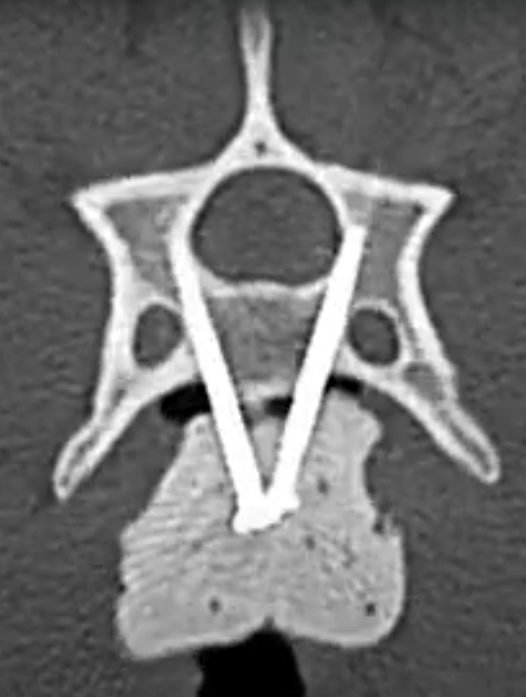
A CT scan performed after surgery to check the accuracy of multiple screws placed into the vertebrae (bones) of the neck.

What can I expect if my pet is treated for ‘Wobbler’ syndrome?
With any treatment, the aim is to reduce pain and improve mobility. Whilst certain ‘lifestyle’ changes and long-term medications may be necessary to prevent worsening, we aim to return to most normal activities, and avoid any long-term medication side effects.

In surgically treated dogs, a few days of postoperative hospitalisation is usually required. Following this, a period of exercise restriction is needed.

Regardless of treatment, many pets benefit from physiotherapy, which we provide through our in-house service provided by qualified veterinary physiotherapists.

